Cambiar header en list
src\sections\member\view\member-list-view.jsx
const TABLE_HEAD = [
{ id: 'name', label: 'Name' },
{ id: 'phoneNumber', label: 'Núm. Teléfono', width: 180 },
// { id: 'company', label: 'Company', width: 220 },
{ id: 'memberDivision', label: 'División', width: 220 },
{ id: 'Role', label: 'Role', width: 180 },
{ id: 'status', label: 'Estado', width: 100 },
{ id: '', width: 88 },
];

src\_mock\_member.js
// company: _mock.companyNames(index),
memberDivision: _mock.memberDivisionNames(index),

src\_mock\_mock.js (importar)
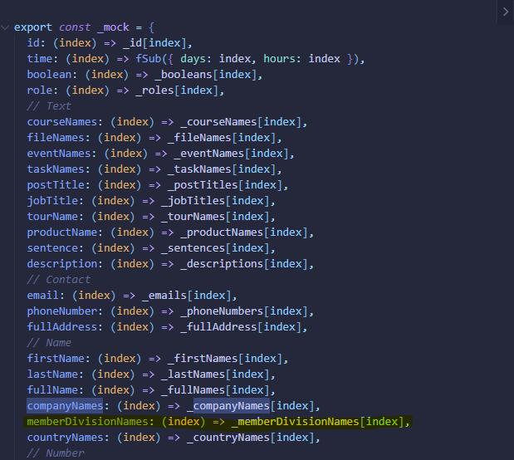
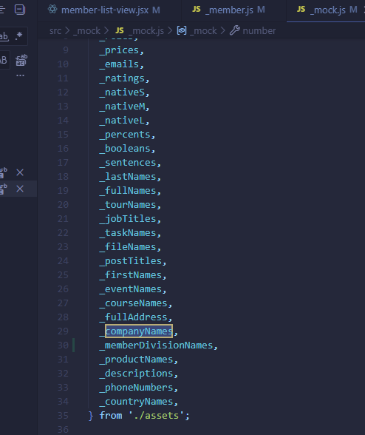
src\_mock\assets.js
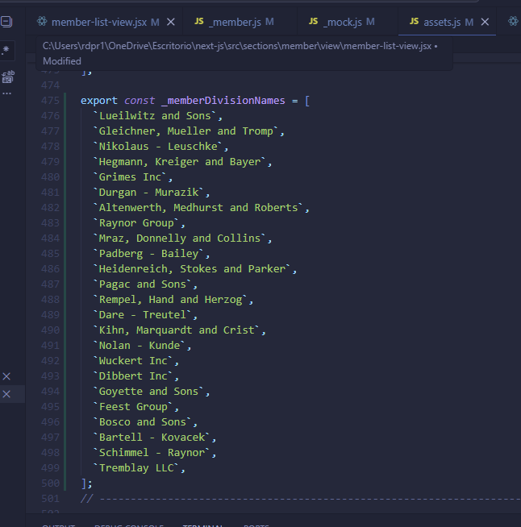

src\sections\member\member-table-row.jsx
<TableCell sx={{ whiteSpace: 'nowrap' }}>{row.memberDivision}</TableCell>

